RANKZY AI — QA FAILED TEST CASES REPORT
Field | Details
Document Title | QA Failed Test Cases Report
Project Name | Rankzy AI
Application URL | https://rankzyai.com
Version | 1.0

Overview
This document contains all the failed test cases identified during the testing of the Rankzy AI application. Each failed test case includes the expected result, actual result, issue description, reproduction steps, supporting evidence, and recommendations for resolution.

2. FUNCTIONAL TESTING

TC-FUN-F02: Weak Areas Report Displays Subject Name Instead of Topic Details
- TC ID: TC-FUN-F02
- Section: Functional Testing
- Priority: Medium | Severity: Medium
- Automation Tool: Google Chrome
- Automation Framework: N/A
- Test Scenario: Verify that the performance report displays detailed weak areas within each subject.
- Expected Result: The report should display topic/chapter-level weak areas (for example, Biology → Plant Physiology, Botany, Genetics).
- Actual Result: The Weak Areas section displays only the subject name, which is the same as the Strong Areas section.
- Execution Status: FAILED
- Issue Description: The report does not provide meaningful topic-level analysis, making it difficult for users to identify improvement areas.
- Steps to Reproduce:
  - Complete a practice test.
  - Open the performance report.
  - Compare the Strong Areas and Weak Areas sections.
- Environment: Production
- Browser: Google Chrome
- Operating System: Windows 11
- Bug ID: BUG-FUN-02

Evidence
Screenshot:
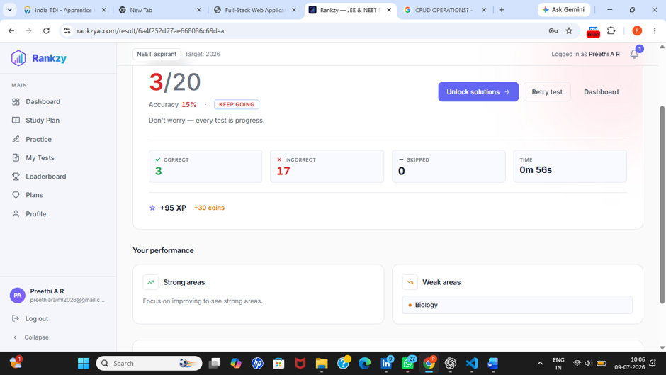
Figure FUN-02: Weak Areas section displays only the subject name instead of detailed topics. - Recommendation: Display chapter/topic-level weak areas instead of repeating the subject name.

UI Testing

TC-UI-F02: Navigation Underline Indicator Misaligned
- TC ID: TC-UI-F02
- Section: UI Testing
- Priority: Low | Severity: Low
- Automation Tool: Google Chrome
- Automation Framework: N/A
- Test Scenario: Verify that the navigation underline aligns correctly with the selected tab.
- Expected Result: The underline indicator should align properly beneath the selected tab (Today, Mocks, PYQ).
- Actual Result: The underline indicator is misaligned beneath the navigation tabs.
- Execution Status: FAILED
- Issue Description: Incorrect alignment affects the visual consistency of the navigation menu.
- Steps to Reproduce:
  - Open the Practice Tests page.
  - Switch between Today, Mocks, and PYQ tabs.
  - Observe the underline indicator.
- Environment: Production
- Browser: Google Chrome
- Operating System: Windows 11
- Bug ID: BUG-UI-02

Evidence
Screenshot:
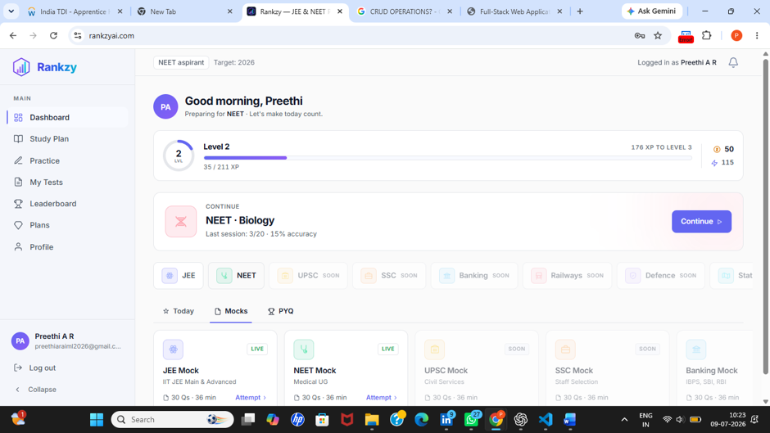 Figure UI-02: Underline indicator is not aligned with the selected navigation tab. - Developer Recommendation: Adjust the CSS styling to align the underline indicator correctly.

TC-UI-F03: Test Legend Colours Are Not Clearly Visible
- TC ID: TC-UI-F03
- Section: UI Testing
- Priority: Medium | Severity: Medium
- Automation Tool: Google Chrome
- Automation Framework: N/A
- Test Scenario: Verify that the legend colours for Answered, Marked, and Unanswered questions are clearly distinguishable.
- Expected Result: Each legend item should have a clear and distinguishable colour with sufficient contrast.
- Actual Result: The legend colours are difficult to distinguish and the colour indicators are not displayed clearly.
- Execution Status: FAILED
- Issue Description: Poor visibility of the legend makes it difficult for users to identify question statuses during a test.
- Steps to Reproduce:
  - Start a practice test.
  - Observe the legend displaying Answered, Marked, and Unanswered.
- Environment: Production
- Browser: Google Chrome
- Operating System: Windows 11
- Bug ID: BUG-UI-03 #### Evidence Screenshot:
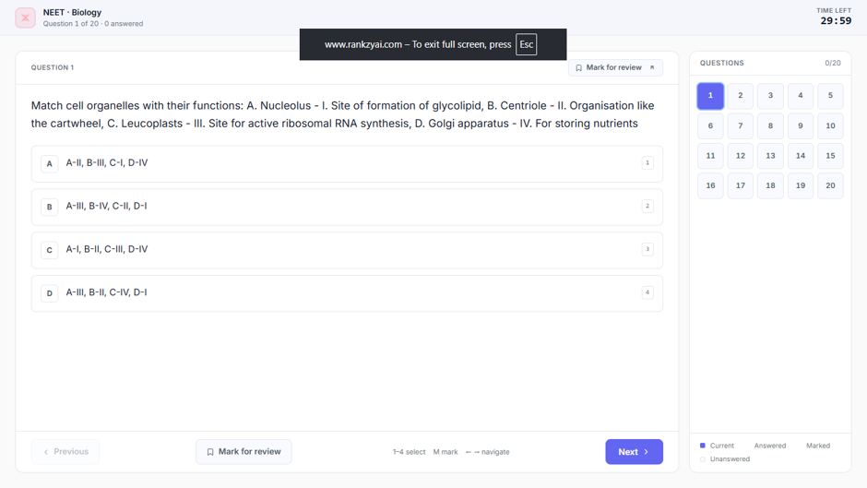
Figure UI-03: Question status legend lacks clear colour visibility.
Developer Recommendation: Improve colour contrast and ensure each legend item displays its corresponding colour indicator.

TC-UI-F04: Dashboard Button Unnecessarily Displayed on Result Page
- TC ID: TC-UI-F04
- Section: UI Testing
- Priority: Low
- Severity: Low
- Automation Tool: Google Chrome
- Automation Framework: N/A
- Test Scenario: Verify that only relevant navigation controls are displayed on the Result page.
- Expected Result: The Result page should display only relevant actions for users.
- Actual Result: An unnecessary Dashboard button is displayed on the Result page.
- Execution Status: FAILED
- Issue Description: The additional Dashboard button creates unnecessary visual clutter on the Result page.
- Steps to Reproduce:
  - Complete a test.
  - Open the Result page.
  - Observe the available action buttons.
- Environment: Production
- Browser: Google Chrome
- Operating System: Windows 11
- Bug ID: BUG-UI-04 #### Evidence Screenshot:
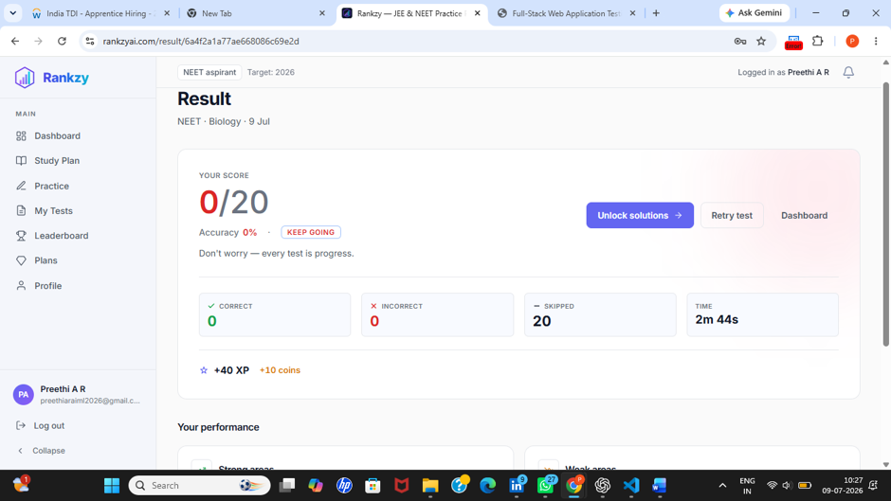
Figure UI-04: Dashboard button displayed unnecessarily on the Result page. - Recommendation: Remove the unnecessary Dashboard button or relocate it appropriately.

TC-UI-F05: Notification Theme Is Inconsistent with Application Theme
- TC ID: TC-UI-F05
- Section: UI Testing
- Priority: Low
- Severity: Low
- Automation Tool: Google Chrome
- Automation Framework: N/A
- Test Scenario: Verify that notification colours follow the application’s design theme.
- Expected Result: Notification colours should match the overall application theme.
- Actual Result: Notification colours are inconsistent with the application’s colour scheme.
- Execution Status: FAILED
- Issue Description: Inconsistent colours reduce the visual consistency of the user interface.
- Steps to Reproduce:
  - Trigger a notification.
  - Compare the notification colours with the application’s theme.
- Environment: Production
- Browser: Google Chrome
- Operating System: Windows 11
- Bug ID: BUG-UI-05

Evidence
Screenshot:
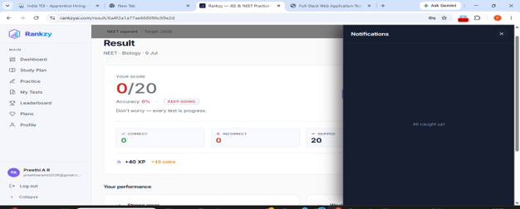
Figure UI-05: Notification color scheme differs from the application theme.
Developer Recommendation: Update the notification styling to match the application’s design system.
- Failed Count: 5
- Critical: 0 | High: 0 | Medium: 2 | Low: 3

5. RESPONSIVE TESTING

TC-RES-F01: Navigation Underline Misaligned on Smaller Screens
- TC ID: TC-RES-F01
- Section: Responsive Testing
- Priority: Low | Severity: Low
- Automation Tool: Google Chrome Responsive Mode
- Automation Framework: N/A
- Test Scenario: Verify that the navigation underline aligns correctly with the selected tab on different screen sizes.
- Expected Result: The underline indicator should remain properly aligned below the selected tab (Today, Mocks, PYQ) on all supported screen sizes.
- Actual Result: The underline indicator becomes misaligned on smaller screen sizes.
- Execution Status: FAILED
- Issue Description: The responsive layout does not maintain proper alignment of the navigation indicator on smaller devices.
- Steps to Reproduce:
  - Open the Practice Tests page.
  - Enable mobile responsive view.
  - Switch between Today, Mocks and PYQ.
  - Observe the underline alignment.
- Environment: Production
- Browser: Google Chrome
- Operating System: Windows 11
- Bug ID: BUG-RES-01 #### Evidence Screenshot:
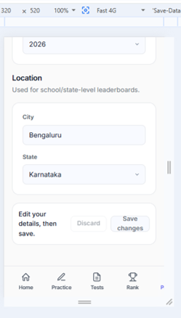
alt text
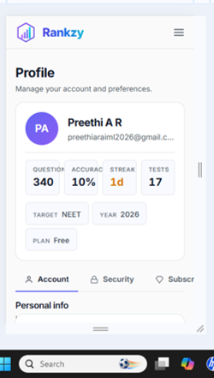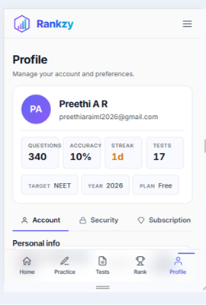
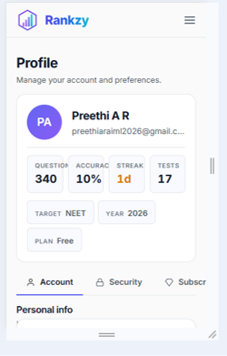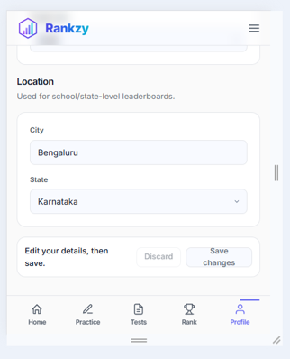
Figure RES-01: Underline indicator and other cards is not aligned correctly on smaller screen sizes. - Recommendation: Adjust the responsive CSS so that the UI remains properly aligned across all supported screen sizes.

TC-RES-F02: Question Status Legend Not Clearly Visible on Mobile Devices
- TC ID: TC-RES-F02
- Section: Responsive Testing
- Priority: Medium | Severity: Medium
- Automation Tool: Google Chrome Responsive Mode
- Automation Framework: N/A
- Test Scenario: Verify that the question status legend is clearly visible on smaller devices.
- Expected Result: Answered, Marked and Unanswered indicators should remain clearly visible with sufficient colour contrast.
- Actual Result: The legend colours are difficult to distinguish on smaller screens.
- Execution Status: FAILED
- Issue Description: Poor colour visibility reduces the usability of the question status legend during tests.
- Steps to Reproduce:
  - Open a practice test.
  - Enable mobile responsive mode.
  - Observe the legend.
- Environment: Production
- Browser: Google Chrome
- Operating System: Windows 11
- Bug ID: BUG-RES-02

Evidence
Screenshot:
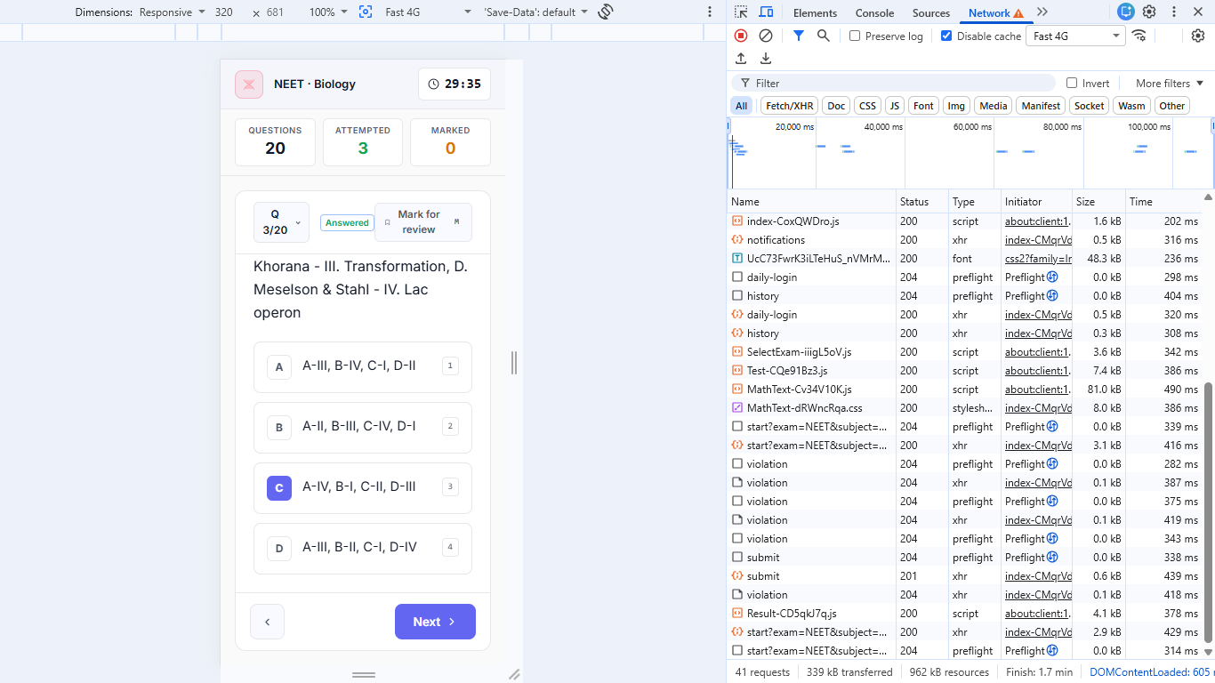

Figure RES-02: Question status legend is difficult to distinguish on screens. - Recommendation: Improve the responsive styling and increase the colour contrast of the legend.

TC-RES-F03: Dashboard Cards Do Not Resize Properly on Small Viewports
- TC ID: TC-RES-F03
- Section: Responsive Testing
- Priority: Medium | Severity: Medium
- Automation Tool: Google Chrome Responsive Mode
- Automation Framework: N/A
- Test Scenario: Verify that dashboard cards resize correctly on different mobile screen sizes.
- Expected Result: Dashboard cards should resize proportionally and remain properly aligned on all supported viewports.
- Actual Result: Dashboard cards do not resize correctly on smaller viewports such as 320px, 375px and 420px, causing inconsistent spacing and layout.
- Execution Status: FAILED
- Issue Description: The responsive layout does not adapt correctly for smaller mobile screen sizes.
- Steps to Reproduce:
  - Open the Dashboard.
  - Enable responsive mode.
  - Test at 320px, 375px and 420px widths.
  - Observe the card layout.
- Environment: Production
- Browser: Google Chrome
- Operating System: Windows 11
- Bug ID: BUG-RES-03
- Recommendation: Update the responsive layout so cards resize consistently across all supported mobile screen sizes.
- Failed Count: 3
- Critical: 0 | High: 0 | Medium: 2 | Low: 1

7. VALIDATION & NEGATIVE TESTING

TC-VAL-F01: Mobile Number Validation Not Enforced
- TC ID: TC-VAL-F01
- Section: Validation & Negative Testing
- Priority: High | Severity: High
- Automation Tool: Google Chrome
- Automation Framework: N/A
- Test Scenario: Verify that the mobile number field accepts only valid mobile numbers of the required length.
- Expected Result: The application should reject mobile numbers with fewer or more digits than the allowed length.
- Actual Result: The application accepts mobile numbers with invalid lengths.
- Execution Status: FAILED
- Issue Description: Mobile number length validation is not enforced, allowing invalid contact information to be saved.
- Steps to Reproduce:
  - Open the Profile page.
  - Edit the mobile number.
  - Enter fewer or more digits than the required length.
  - Save the changes.
- Environment: Production
- Browser: Google Chrome
- Operating System: Windows 11
- Bug ID: BUG-VAL-01

Evidence
Screenshot: 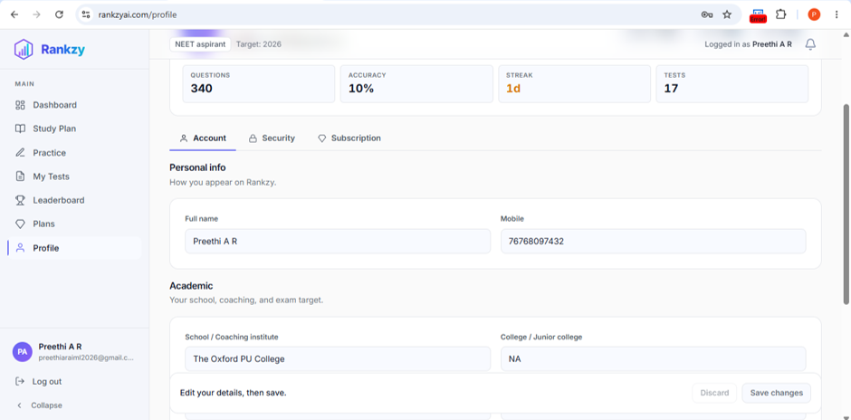
Figure VAL-01: Mobile number field accepts invalid lengths.
- Recommendation: Enforce minimum and maximum length validation for the mobile number field.

TC-VAL-F02: OTP Verification Proceeds Without Mandatory Profile Details
- TC ID: TC-VAL-F02
- Section: Validation & Negative Testing
- Priority: High | Severity: High
- Automation Tool: Google Chrome
- Automation Framework: N/A
- Test Scenario: Verify that mandatory profile fields are validated before OTP verification.
- Expected Result: OTP verification should not proceed until all mandatory profile fields are completed.
- Actual Result: OTP verification proceeds even when mandatory profile fields are left empty.
- Execution Status: FAILED
- Issue Description: Required field validation is missing before OTP verification.
- Steps to Reproduce:
  - Open the Profile section.
  - Leave the mandatory fields empty.
  - Proceed with OTP verification.
- Environment: Production
- Browser: Google Chrome
- Operating System: Windows 11
- Bug ID: BUG-VAL-02
- Recommendation: Validate all required profile fields before allowing OTP verification.

TC-VAL-F03: Profile Fields Accept Special Characters
- TC ID: TC-VAL-F03
- Section: Validation & Negative Testing
- Priority: Medium | Severity: Medium
- Automation Tool: Google Chrome
- Automation Framework: N/A
- Test Scenario: Verify that profile fields reject invalid special characters where they are not allowed.
- Expected Result: Fields such as Name and Mobile Number should reject invalid special characters.
- Actual Result: Profile fields accept special characters without validation.
- Execution Status: FAILED
- Issue Description: Input validation does not restrict unsupported special characters.
- Steps to Reproduce:
  - Open the Profile page.
  - Enter special characters into applicable fields.
  - Save the profile.
- Environment: Production
- Browser: Google Chrome
- Operating System: Windows 11
- Bug ID: BUG-VAL-03

Evidence
Screenshot:
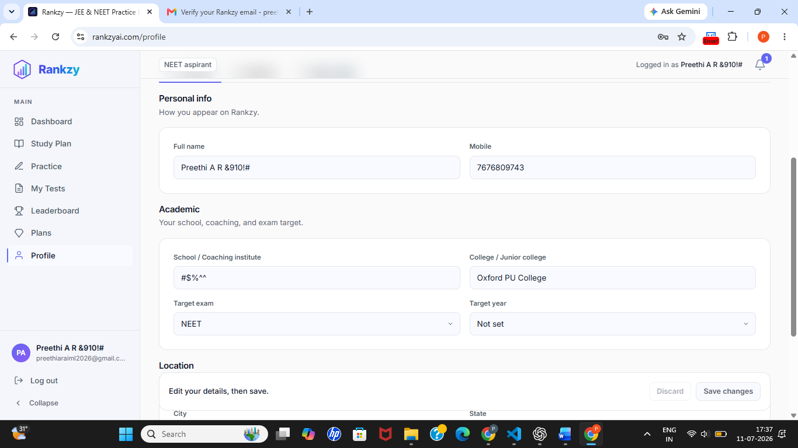
Figure VAL-03: Profile fields accept unsupported special characters.
Recommendation: Validate input fields and restrict unsupported special characters where appropriate.

TC-VAL-F04: Invalid Input Accepted in Profile Fields
- TC ID: TC-VAL-F04
- Section: Validation & Negative Testing
- Priority: Medium | Severity: Medium
- Automation Tool: Google Chrome
- Automation Framework: N/A
- Test Scenario: Verify that invalid input values are rejected.
- Expected Result: Invalid input should be rejected with an appropriate validation message.
- Actual Result: Invalid input values are accepted.
- Execution Status: FAILED
- Issue Description: Input validation is insufficient for profile fields.
- Steps to Reproduce:
  - Open the Profile page.
  - Enter invalid values into editable fields.
  - Save the changes.
- Environment: Production
- Browser: Google Chrome
- Operating System: Windows 11
- Bug ID: BUG-VAL-04
- Evidence Screenshot:

Figure VAL-04: Invalid profile input accepted without validation.
Recommendation: Apply appropriate validation rules before accepting user input.

TC-VAL-F05: Maximum Character Length Validation Missing
- TC ID: TC-VAL-F05
- Section: Validation & Negative Testing
- Priority: Medium | Severity: Medium
- Automation Tool: Google Chrome
- Automation Framework: N/A
- Test Scenario: Verify that profile fields enforce maximum character limits.
- Expected Result: Profile fields should reject input exceeding the defined maximum length.
- Actual Result: No maximum character limit is enforced for fields such as Name and Mobile Number.
- Execution Status: FAILED
- Issue Description: Missing character limits allow excessively long input values.
- Steps to Reproduce:
  - Open the Profile page.
  - Enter values exceeding a reasonable character limit.
  - Save the profile.
- Environment: Production
- Browser: Google Chrome
- Operating System: Windows 11
- Bug ID: BUG-VAL-05

Evidence
Screenshot:

Figure VAL-05: No maximum character limit enforced. - Recommendation: Define and enforce appropriate maximum character limits for all profile fields.
- Failed Count: 5
- Critical: 0 | High: 2 | Medium: 3 | Low: 0

9. BOUNDARY VALUE TESTING

TC-BVA-F01: Password Maximum Length Validation Not Enforced
- TC ID: TC-BVA-F01
- Section: Boundary Value Testing
- Priority: Medium | Severity: Medium
- Automation Tool: Google Chrome
- Automation Framework: N/A
- Test Scenario: Verify that the password field enforces a maximum character limit.
- Expected Result: Passwords exceeding the maximum allowed length should be rejected with an appropriate validation message.
- Actual Result: Passwords exceeding the expected maximum length were accepted without validation.
- Execution Status: FAILED
- Issue Description: The application does not enforce a maximum password length, allowing excessively long passwords to be entered.
- Steps to Reproduce:
  - Open the Sign Up or Profile page.
  - Enter a password longer than the expected maximum length.
  - Submit the form.
- Environment: Production
- Browser: Google Chrome
- Operating System: Windows 11
- Bug ID: BUG-BVA-01

Evidence
Screenshot:
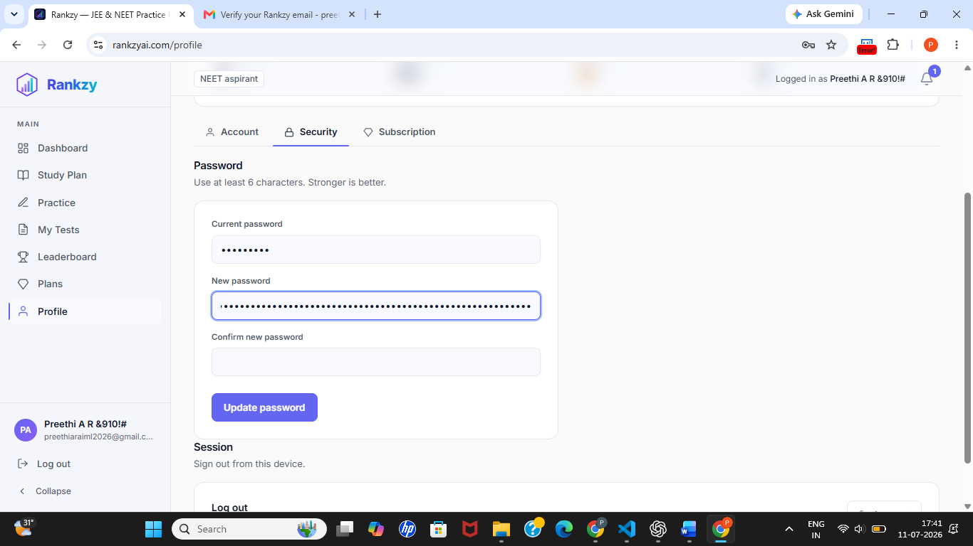
Figure BVA-01: Password field accepts input beyond the expected maximum length. - Recommendation: Define and enforce a maximum password length with appropriate validation.

TC-BVA-F02: Maximum Character Limits Not Defined for Profile Fields
- TC ID: TC-BVA-F02
- Section: Boundary Value Testing
- Priority: Medium | Severity: Medium
- Automation Tool: Google Chrome
- Automation Framework: N/A
- Test Scenario: Verify that profile fields enforce maximum character limits.
- Expected Result: Fields such as Name and Mobile Number should reject input exceeding the defined maximum length.
- Actual Result: No maximum character limit is enforced for profile fields, allowing excessively long input values.
- Execution Status: FAILED
- Issue Description: Missing boundary validation allows users to enter values beyond reasonable limits.
- Steps to Reproduce:
  - Open the Profile page.
  - Enter a very long value into editable fields.
  - Save the profile.
- Environment: Production
- Browser: Google Chrome
- Operating System: Windows 11
- Bug ID: BUG-BVA-02

Evidence
Screenshot:
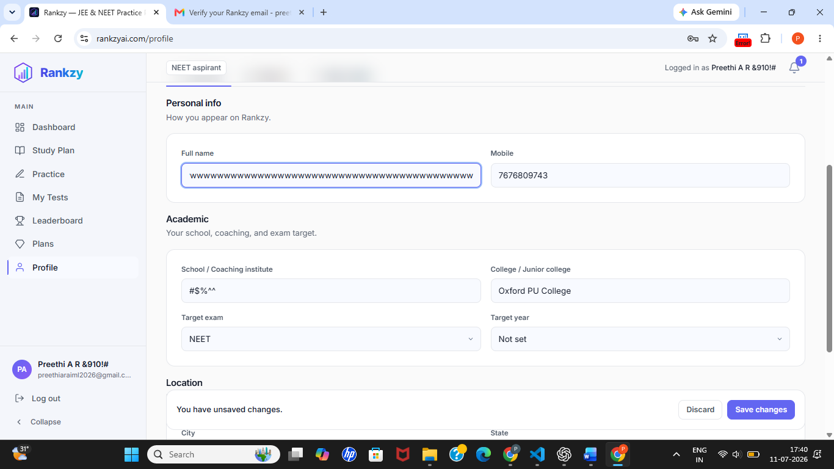
Figure BVA-02: Profile fields accept excessively long input values.
Recommendation: Define and enforce maximum character limits for all applicable profile fields.
- Failed Count: 2
- Critical: 0 | High: 0 | Medium: 2 | Low: 0

10. ERROR HANDLING TESTING

TC-ERR-F01: Session Expiration Handling Not Implemented
- TC ID: TC-ERR-F01
- Section: Error Handling Testing
- Priority: Medium | Severity: Medium
- Automation Tool: Google Chrome
- Automation Framework: N/A
- Test Scenario: Verify that the application automatically expires inactive user sessions and prompts the user to log in again.
- Expected Result: After a period of inactivity, the session should expire automatically and redirect the user to the login page or display a session expiration message.
- Actual Result: The application did not automatically expire the session during the observed testing period.
- Execution Status: FAILED
- Issue Description: Automatic session expiration is not enforced, allowing inactive sessions to remain active.
- Steps to Reproduce:
  - Log in to the application.
  - Leave the application idle for an extended period.
  - Return to the application and observe the session status.
- Environment: Production
- Browser: Google Chrome
- Operating System: Windows 11
- Bug ID: BUG-ERR-01

Evidence
Session remained active after prolonged inactivity. R
Recommendation: Implement automatic session expiration after a configurable period of inactivity and notify users before redirecting them to the login page.
- Failed Count: 1
- Critical: 0 | High: 0 | Medium: 1 | Low: 0

12. PERFORMANCE TESTING

TC-PER-F01: GTmetrix Audit Could Not Be Completed Due to Lighthouse Error
- TC ID: TC-PER-F01
- Section: Performance Testing
- Priority: Low | Severity: Low
- Automation Tool: GTmetrix
- Automation Framework: N/A
- Test Scenario: Verify that the application can be successfully analyzed using GTmetrix.
- Expected Result: GTmetrix should complete the performance analysis and generate a performance report with Lighthouse metrics.
- Actual Result: GTmetrix failed to complete the analysis because Lighthouse encountered an internal error during report generation.
- Execution Status: FAILED
- Issue Description: Performance metrics could not be generated through GTmetrix due to a Lighthouse execution error.
- Steps to Reproduce:
  - Open GTmetrix.
  - Enter https://www.rankzyai.com.
  - Start the performance analysis.
  - Observe the generated result.
- Environment: GTmetrix (Web)
- Browser: Google Chrome
- Operating System: Windows 11
- Bug ID: BUG-PER-01

Evidence
Screenshot:
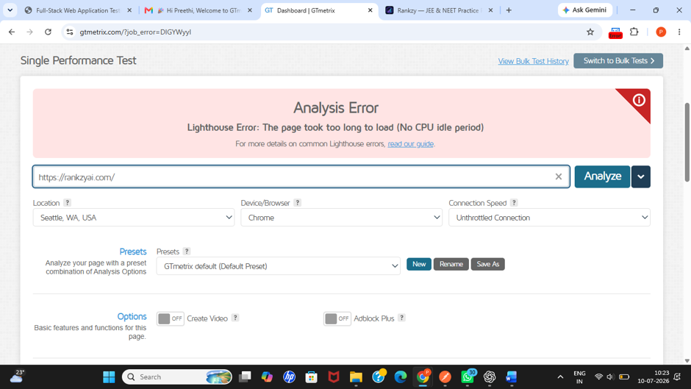
Figure PER-01: GTmetrix failed to generate the performance report because Lighthouse encountered an error. - Recommendation: Review the GTmetrix/Lighthouse error details, verify the application’s accessibility during testing, and rerun the audit after resolving any configuration or connectivity issues.
- Failed Count: 1
- Critical: 0 | High: 0 | Medium: 0 | Low: 1

13. SESSION TESTING

TC-SES-F01: Auto Logout After Inactivity Not Implemented
- TC ID: TC-SES-F01
- Section: Session Testing
- Priority: High | Severity: High
- Automation Tool: Google Chrome
- Automation Framework: N/A
- Test Scenario: Verify that the application automatically logs out inactive users after the configured inactivity timeout.
- Expected Result: The application should automatically terminate the user session after a period of inactivity and redirect the user to the login page.
- Actual Result: The user session remained active even after prolonged inactivity and no automatic logout occurred.
- Execution Status: FAILED
- Issue Description: The application does not automatically terminate inactive sessions, which may expose authenticated accounts if devices are left unattended.
- Steps to Reproduce:
  - Log in to the application.
  - Leave the application inactive for an extended period.
  - Return to the application.
  - Observe the session status.
- Environment: Production
- Browser: Google Chrome
- Operating System: Windows 11
- Bug ID: BUG-SES-01
- Recommendation: Implement automatic session timeout after a configurable inactivity period and redirect users to the login page when the session expires.
- Failed Count: 1s
- Critical: 0 | High: 1 | Medium: 0 | Low: 0

